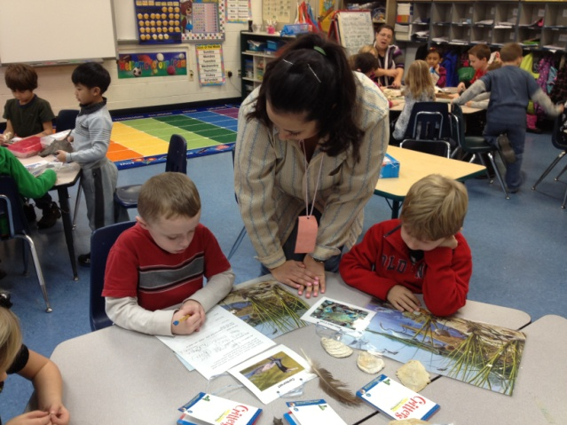
Please join us for a curriculum workshop to prepare students for A Day in the Life of the Hudson River. Designed for teachers and educators to integrate “Day in the Life” into existing classroom curriculum. Extend your river study beyond the field event!

A Day in the Life of the Hudson River CLASSROOM

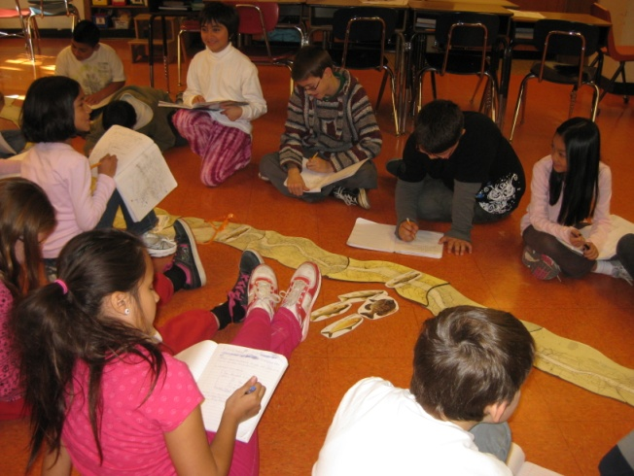

Workshops will provide hands on activities for your classroom to strengthen learning before and after the field event. Small group focus and discussion will address the varied student ages and abilities.

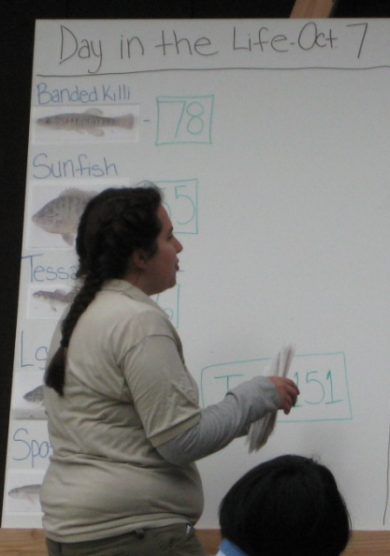

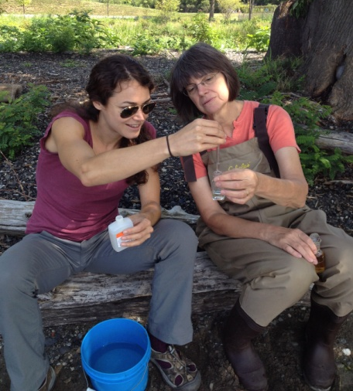
*NEW WORKSHOP 2013 Specifically designed for HS teachers & educators!
Building Day in the Life Data into Classroom Curricula – “Sharing Practical Ideas and Strategies"
Now we have the data…what next? Join us for a workshop focusing on how to engage students in working directly with the data. Bring Day in the Life, and remotely sensed Hudson River data, into your classroom teaching. Bring your questions & suggestions!

What is A Day in the Life? Environmental centers and school classes all along the Hudson River estuary collect scientific information and share it to create a picture of "A Day in the Life of the Hudson River." This annual program helps participants understand how their piece of the river fits into the larger Hudson estuary ecosystem.

I WOULD LIKE TO REGISTER FOR THE FOLLOWING CURRICULUM WORKSHOP(S):

_____ August 15th, Thursday. 10-1 PM, - Beczak Environmental Education Center, 35 Alexander St., Yonkers, NY
_____August 21st, Wed. 10-3:30 PM – Special High School Program on: Building Day in the Life Data into Classroom Curricula - Sharing Practical Ideas and Strategies. Lamont-Doherty Earth Observatory, 61 Route 9W, Palisades, NY.

PLEASE fax or email the registration form to Rebecca Houser at rlhouser@gw.dec.state.ny.us. Fax: 845-255-3649.

Name _______________________________________________Organization or school __________________________

School District ____________________________________________Grade taught______________________________

Address _____________________________________________City _______________________State_____Zip________

E-mail____________________________________________________Phone ____________________________________

…………………………………………………………………………………………………..





Visit a Day in the Life website:
www.dec.ny.gov/lands/47285.html
http://www.ldeo.columbia.edu/edu/k12/snapshotday/

